Unit 3.7 - Short Run and Long Run Equlibrium of AD/AS
- How does the automatic adjustment mechanism move the economy to potential real gross domestic product (GDP) in the long run when current real GDP is above potential GDP?
- Nominal wages fall, shifting the SRAS curve to the right.
- Nominal wages fall, shifting the SRAS to the left.
- Nominal wages do not change, shifting the SRAS to the right.
- Nominal wages rise, shifting the SRAS curve to the right.
- Nominal wages rise, shifting the SRAS to the left.
- In the long run, if AD decreases, RGDP and the price level will change in which of the following ways.
 | Real GDP | Price Level
A | Decrease | Decrease
B | Decrease | Increase
C | No change | Decrease
D | Increase | Decrease
E | No change | Increase
- According to the graph, what is true about the long run equilibrium?
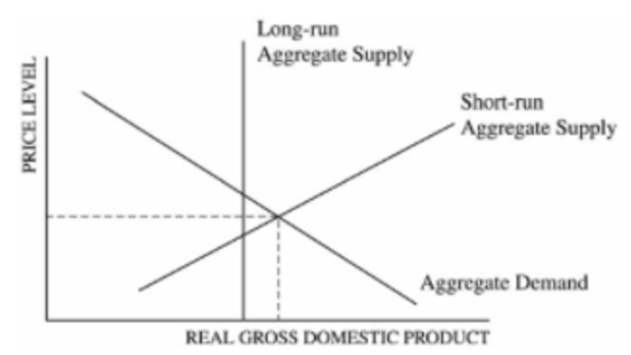
- The economy is in long run equilibrium.
- The AD curve will shift to the left to restore long run equilibrium.
- The LRAS will shift to the right to restore long run equilibrium.
- Without a fiscal policy stimulus, the economy will remain in a recession.
- As wages increase, the SRAS will shift to the left to restore long run equilibrium.

- According to the graph above and starting with equilibrium point R, which of the following shifts identifies the short-run and the long-run impact of a demand-pull inflation?
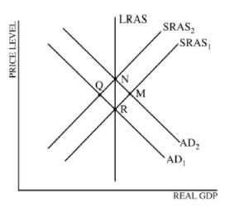
 | Short Run | Long Run
A | R to N | M to N
B | R to M | R to N
C | R to Q | Q to N
D | R to M | R to Q
E | R to N | N to Q

- Assume the countries of Nornania and Kumbagi are major trading partners. Ornania is currently in long run equilibrium. As a result of a recession in its economy, Kumbagi decreases its demand for goods produced in Ornania. Which of the following will occur in Ornania in the short run?
- The AD will shift to the right, causing the actual rate of unemployment to exceed the natural rate of unemployment.
- The aggregate demand curve will shift to the left, resulting in an inflationary gap.
- Aggregate demand curve will shift to the left, resulting in a recessionary gap.
- The short run aggregate supply curve will shift to the left resulting in an inflationary gap.
- The short run aggregate supply curve will shift to the left, resulting in a recessionary gap.
- Assume that a country is operating at less than full employment.
- Draw a correctly labeled graph of aggregate demand and aggregate supply, and show each of the following.
- Long run aggregate supply curve.
- Current output and price level.

- Assume that policy makers take no policy action and that prices and wages are flexible. Explain what will happen to each of the following.
- Short run aggregate supply
- Employment

- If a change in AD results in a recession, the price level and output will change in which of the following ways in the short run?
 | Price Level | Real Output
A | No change | Increase
B | Increase | No change
C | Increase | Decrease
D | Decrease | No change
E | Decrease | Decrease
- The graph above depicts an economy’s aggregate demand and aggregate supply curves. If aggregate demand remains constant, the equilibrium price levels in the short run and in the long run will be which o the following?
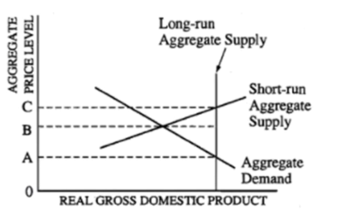
 | Short Run | Long Run
A | OA | OA
B | OB | OA
C | OB | OC
D | OC | OA
E | OC | OC

- Assume the economy is currently in long run equilibrium. An increase in incomes in a neighboring country will affect unemployment in the short run and in the long run in which of the following ways?
 | Short Run | Long Run
A | Falls | Falls
B | Rises | Rises
C | No change | Remains at the natural rate
D | Rises above the natural rate | Falls back to the natural rate
E | Falls below the natural rate | Rises back to the natural rate

- An economy is currently in short run equilibrium, and real output is below the full employment level of output. Which of the following market adjustments is most likely to occur in the long run?
- The recessionary gap will create upward pressure on prices, shifting the aggregate demand cure to the left.
- The existence of cyclical unemployment will increase consumption spending and increase real output.
- Full employment output will fall to equal the short run equilibrium real output.
- Nominal wages will fall, shifting the short run aggregate supply curve to the right.
- Input prices will increase as firms compete for labor and capital.

- Based on the diagram above, which of the following describes what will happen in the long run adjustment process.
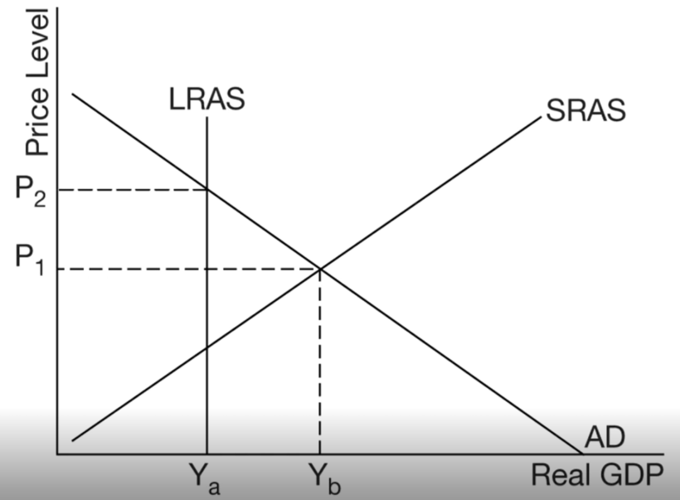
- The natural rate of unemployment will increase
- Potential real GDP will increase.
- Aggregate demand will decrease.
- Short run aggregate supply will increase.
- Wages and input prices will increase.
- The economy of a country is currently in equilibrium at point A in the diagram above. If the government does nothing and wages are flexible, which of the following will most likely occur in the long run?
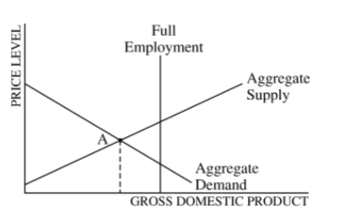
- Falling wages will shift the AD curve to the right, producing full employment.
- Rising wages will shift the aggregate demand curve to the right, producing full employment.
- The economy will remain at point A.
- Rising wages will shift the aggregate supply curve to the right, producing full employment.
- Falling wages will shift the aggregate supply curve to the right producing full employment.
- If there is a temporary supply shock which causes stagflation in the economy, what will happen to the economy in the long run?
- The AD will shift to the right to restore long run equilibrium.
- The SRAS will shift back to the original level because the supply shock was only temporary.
- The higher price level will cause higher wages which will shift the SRAS even further to the left.
- There will be a fall in the price level due to lower AD.
- There will be a shift of the LRAS.

1 | E | 6 |  | 11 | E
2 | C | 7 | E | 12 | E
3 | E | 8 | B
4 | B | 9 | E
5 | C | 10 | D

6. a) 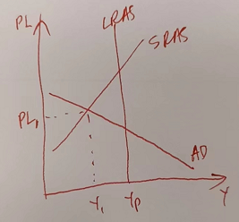
b) SRAS will shift to the right. (If this is caused by AD change, then the lower price level will eventually lead to lower wages in the long run, causing SRAS to shift right.)
Employment will increase

